|  |  |
| --- | --- |
| Report date | Jun 7, 2025, 8:25:34 AM |

[](https://www.comsol.com/)

**Numerical Simulation of Electrokinetic Self-Potential response to subsurface fluid flow**

This study implements forward numerical modeling of self-potential (SP) signals using COMSOL Multiphysics 6.1 to simulate coupled fluid flow and electrokinetic processes in variably saturated porous media. The model couples Richards’ equation for unsaturated flow with electric current conservation, incorporating electrokinetic source terms derived from excess charge density (*Q*ˉ*V*) and Darcy velocity (**u**). Key parameters include hydraulic conductivity (*Ks*), van Genuchten retention parameters (*α*,*n*,*θr*), and electrical conductivity (*σ*).

Contents

1. Global Definitions

1.1. Parameters

1.2. Shared Properties

2. Component 1

2.1. Definitions

2.2. Geometry 1

2.3. Darcy's Law

2.4. Electric Currents

2.5. Mesh 1

3. Study 1

3.1. Time Dependent

3.2. Solver Configurations

4. Results

4.1. Datasets

4.2. Plot Groups

1. Global Definitions

|  |  |
| --- | --- |
| Date | Jun 4, 2025, 11:44:57 PM |

Used products

|  |
| --- |
| Battery Design Module |
| COMSOL Multiphysics |

Computer information

|  |  |
| --- | --- |
| CPU | Intel64 Family 6 Model 154 Stepping 4, 12 cores, 7.69 GB RAM |
| Operating system | Windows 10 |

* 1. Parameters

Parameters 1

| **Name** | **Expression** | **Value** | **Description** |
| --- | --- | --- | --- |
| rho_f | 1000 | 1000 |  |
| eta_f | 1.14E-3 | 0.00114 |  |
| phi | 0.33 | 0.33 |  |
| K | 8E-5 | 8E−5 |  |
| sigma_sat | 0.012 | 0.012 |  |
| Qv | 0.48 [C/m^3] | 0.48 C/m³ |  |
| g | 9.82 [m/s^2] | 9.82 m/s² |  |

* 1. Shared Properties
     1. Default Model Inputs

|  |  |
| --- | --- |
| Tag | cminpt |

1. Component 1

|  |  |
| --- | --- |
| Date | May 13, 2025, 3:46:24 PM |

Settings

| **Description** | **Value** |
| --- | --- |
| Unit system | Same as global system (SI) |
| Geometry shape function | Automatic |

Spatial frame coordinates

| **First** | **Second** | **Third** |
| --- | --- | --- |
| x | y | z |

Material frame coordinates

| **First** | **Second** | **Third** |
| --- | --- | --- |
| X | Y | Z |

Geometry frame coordinates

| **First** | **Second** | **Third** |
| --- | --- | --- |
| Xg | Yg | Zg |

Mesh frame coordinates

| **First** | **Second** | **Third** |
| --- | --- | --- |
| Xm | Ym | Zm |

* 1. Definitions
     1. Variables

#### Variables 1

Selection

|  |  |
| --- | --- |
| Geometric entity level | Entire model |

| **Name** | **Expression** | **Unit** | **Description** |
| --- | --- | --- | --- |
| js_x | Qv * dl.UX + eps | A/m² |  |
| js_y | Qv * dl.UY + eps | A/m² |  |

* + 1. Coordinate Systems

#### Boundary System 1

|  |  |
| --- | --- |
| Coordinate system type | Boundary system |
| Tag | sys1 |

Coordinate names

| **First** | **Second** | **Third** |
| --- | --- | --- |
| t1 | n | to |

* 1. Geometry 1

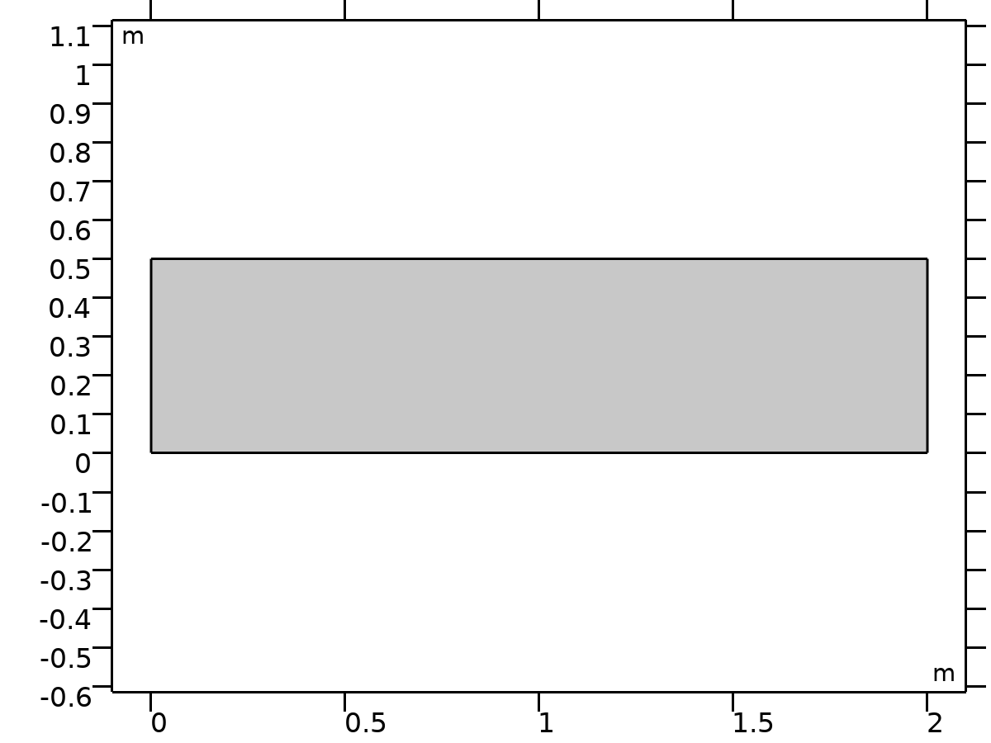

Geometry 1

Units

|  |  |
| --- | --- |
| Length unit | m |
| Angular unit | deg |

Geometry statistics

| **Description** | **Value** |
| --- | --- |
| Space dimension | 2 |
| Number of domains | 1 |
| Number of boundaries | 4 |
| Number of vertices | 4 |

* + 1. Rectangle 1 (r1)

Position

| **Description** | **Value** |
| --- | --- |
| Position | {0, 0} |

Size

| **Description** | **Value** |
| --- | --- |
| Width | 2 |
| Height | 0.5 |

* 1. Darcy's Law

Used products

|  |
| --- |
| Battery Design Module |
| COMSOL Multiphysics |

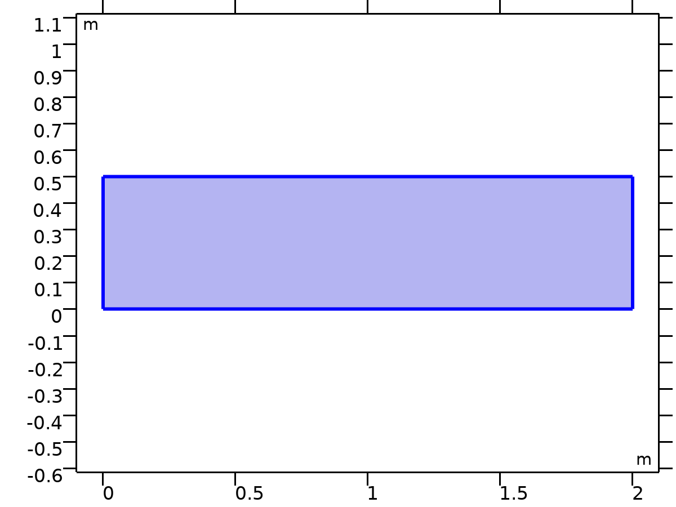

Darcy's Law

Selection

|  |  |
| --- | --- |
| Geometric entity level | Domain |
| Selection | Geometry geom1: Dimension 2: All domains |

Equations

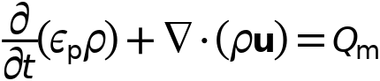

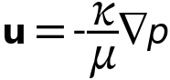

* + 1. Interface Settings

#### Discretization

Settings

| **Description** | **Value** |
| --- | --- |
| Pressure | Quadratic |

Settings

| **Description** | **Value** |
| --- | --- |
| Equation form | Study controlled |

#### Physical Model

Settings

| **Description** | **Value** | **Unit** |
| --- | --- | --- |
| Thickness | 1 | m |
| Reference pressure level | 1.0133E5 | Pa |

#### Gravity Effects

Settings

| **Description** | **Value** | **Unit** |
| --- | --- | --- |
| Include gravity | Off |  |
| Acceleration of gravity | g_const | m/s² |

* + 1. Variables

| **Name** | **Expression** | **Unit** | **Description** | **Selection** |
| --- | --- | --- | --- | --- |
| dl.dz | 1[m] | m | Thickness | Domain 1 |
| dl.pref | 1[atm] | Pa | Reference pressure level | Domain 1 |
| dl.pA | p+dl.pref | Pa | Absolute pressure | Domain 1 |
| dl.d | dl.dz | m | Thickness | Domain 1 |
| dl.nX | dnX | 1 | Normal vector, X-component | Boundaries 1–4 |
| dl.nY | dnY | 1 | Normal vector, Y-component | Boundaries 1–4 |
| dl.nZ | 0 | 1 | Normal vector, Z-component | Boundaries 1–4 |
| dl.g | g_const | m/s² | Acceleration of gravity | Domain 1 |
| dl.H | p/(dl.g*dl.rho)+dl.D | m | Hydraulic head | Domain 1 |
| dl.Hp | p/(dl.g*dl.rho) | m | Pressure head | Domain 1 |
| dl.dHpdt | d(dl.Hp,t) | m/s | Time change in pressure head | Domain 1 |
| dl.D | 0 | m | Elevation | Domain 1 |
| dl.gvect1 | 0 | m/s² | Gravity acceleration vector, 1-component | Domain 1 |
| dl.gvect2 | 0 | m/s² | Gravity acceleration vector, 2-component | Domain 1 |
| dl.gvect3 | 0 | m/s² | Gravity acceleration vector, 3-component | Domain 1 |
| dl.ag1 | 0 | m/s² | Help variable, 1-component | Domain 1 |
| dl.ag2 | 0 | m/s² | Help variable, 2-component | Domain 1 |
| dl.ag3 | 0 | m/s² | Help variable, 3-component | Domain 1 |
| dl.rrefX | 0 | m | Reference position, X-component | Domain 1 |
| dl.rrefY | 0 | m | Reference position, Y-component | Domain 1 |
| dl.rrefZ | 0 | m | Reference position, Z-component | Domain 1 |

* + 1. Porous Medium 1



Porous Medium 1

Selection

|  |  |
| --- | --- |
| Geometric entity level | Domain |
| Selection | Geometry geom1: Dimension 2: All domains |

Equations

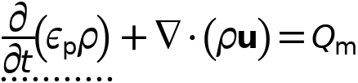

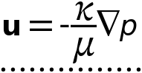

#### Porous Medium

Settings

| **Description** | **Value** |
| --- | --- |
| Flow model | Darcian flow |
| Storage model | From density and porosity |

#### Coordinate System Selection

Settings

| **Description** | **Value** |
| --- | --- |
| Coordinate system | Global coordinate system |

#### Variables

| **Name** | **Expression** | **Unit** | **Description** | **Selection** | **Details** |
| --- | --- | --- | --- | --- | --- |
| domflux.pX | dl.rho*dl.UX | kg/(m²·s) | Domain flux, X-component | Domain 1 |  |
| domflux.pY | dl.rho*dl.UY | kg/(m²·s) | Domain flux, Y-component | Domain 1 |  |
| dl.rho | dl.porous.fluid.rho | kg/m³ | Density | Domain 1 |  |
| dl.kappaXX | dl.porous.pm.kappaXX | m² | Permeability, XX-component | Domain 1 |  |
| dl.kappaYX | dl.porous.pm.kappaYX | m² | Permeability, YX-component | Domain 1 |  |
| dl.kappaZX | dl.porous.pm.kappaZX | m² | Permeability, ZX-component | Domain 1 |  |
| dl.kappaXY | dl.porous.pm.kappaXY | m² | Permeability, XY-component | Domain 1 |  |
| dl.kappaYY | dl.porous.pm.kappaYY | m² | Permeability, YY-component | Domain 1 |  |
| dl.kappaZY | dl.porous.pm.kappaZY | m² | Permeability, ZY-component | Domain 1 |  |
| dl.kappaXZ | dl.porous.pm.kappaXZ | m² | Permeability, XZ-component | Domain 1 |  |
| dl.kappaYZ | dl.porous.pm.kappaYZ | m² | Permeability, YZ-component | Domain 1 |  |
| dl.kappaZZ | dl.porous.pm.kappaZZ | m² | Permeability, ZZ-component | Domain 1 |  |
| dl.mu | dl.porous.fluid.mu | Pa·s | Dynamic viscosity | Domain 1 |  |
| dl.nu | dl.mu/dl.rho | m²/s | Kinematic viscosity | Domain 1 |  |
| dl.Sp | 0 | 1/Pa | Storage | Domain 1 | + operation |
| dl.TraXX | dl.kappaXX/dl.mu | m³·s/kg | Transmissibility, XX-component | Domain 1 |  |
| dl.TraYX | dl.kappaYX/dl.mu | m³·s/kg | Transmissibility, YX-component | Domain 1 |  |
| dl.TraZX | dl.kappaZX/dl.mu | m³·s/kg | Transmissibility, ZX-component | Domain 1 |  |
| dl.TraXY | dl.kappaXY/dl.mu | m³·s/kg | Transmissibility, XY-component | Domain 1 |  |
| dl.TraYY | dl.kappaYY/dl.mu | m³·s/kg | Transmissibility, YY-component | Domain 1 |  |
| dl.TraZY | dl.kappaZY/dl.mu | m³·s/kg | Transmissibility, ZY-component | Domain 1 |  |
| dl.TraXZ | dl.kappaXZ/dl.mu | m³·s/kg | Transmissibility, XZ-component | Domain 1 |  |
| dl.TraYZ | dl.kappaYZ/dl.mu | m³·s/kg | Transmissibility, YZ-component | Domain 1 |  |
| dl.TraZZ | dl.kappaZZ/dl.mu | m³·s/kg | Transmissibility, ZZ-component | Domain 1 |  |
| dl.gradp_mag | sqrt(eps+pX^2+pY^2) | N/m³ | Pressure gradient, magnitude | Domain 1 |  |
| dl.epsilon | dl.porous.pm.epsilon | 1 | Porosity | Domain 1 | + operation |
| dl.kappa_mean | 0.5*(dl.porous.pm.kappaXX+dl.porous.pm.kappaYY) | m² | Mean effective permeability | Domain 1 |  |
| dl.chif | dl.porous.fluid.chif | 1/Pa | Compressibility of fluid | Domain 1 |  |
| dl.dp | dl.porous.pm.dp | m | Particle diameter | Domain 1 |  |
| dl.cf | dl.porous.pm.cf | 1 | Forchheimer parameter | Domain 1 |  |
| dl.u | spatial.F11*dl.UX+spatial.F21*dl.UY | m/s | Darcy's velocity field, x-component | Domain 1 |  |
| dl.v | spatial.F12*dl.UX+spatial.F22*dl.UY | m/s | Darcy's velocity field, y-component | Domain 1 |  |
| dl.w | dl.UZ | m/s | Darcy's velocity field, z-component | Domain 1 |  |
| dl.UX | -dl.TraXX*pX-dl.TraXY*pY+dl.ugX | m/s | Darcy's velocity field, X-component | Domain 1 | + operation |
| dl.UY | -dl.TraYX*pX-dl.TraYY*pY+dl.ugY | m/s | Darcy's velocity field, Y-component | Domain 1 | + operation |
| dl.UZ | -dl.TraZX*pX-dl.TraZY*pY+dl.ugZ | m/s | Darcy's velocity field, Z-component | Domain 1 | + operation |
| dl.ugX | dl.rho*(dl.TraXX*dl.ag1+dl.TraXY*dl.ag2+dl.TraXZ*dl.ag3) | m/s | Gravity contribution to Darcy velocity field, X-component | Domain 1 |  |
| dl.ugY | dl.rho*(dl.TraYX*dl.ag1+dl.TraYY*dl.ag2+dl.TraYZ*dl.ag3) | m/s | Gravity contribution to Darcy velocity field, Y-component | Domain 1 |  |
| dl.ugZ | dl.rho*(dl.TraZX*dl.ag1+dl.TraZY*dl.ag2+dl.TraZZ*dl.ag3) | m/s | Gravity contribution to Darcy velocity field, Z-component | Domain 1 |  |
| dl.U | sqrt(dl.u^2+dl.v^2+dl.w^2) | m/s | Darcy's velocity magnitude | Domain 1 |  |
| dl.ul1 | spatial.invF11*dl.u+spatial.invF21*dl.v | m/s | Darcy's velocity field, local coordinate system, X-component | Domain 1 |  |
| dl.ul2 | spatial.invF12*dl.u+spatial.invF22*dl.v | m/s | Darcy's velocity field, local coordinate system, Y-component | Domain 1 |  |
| dl.ul3 | dl.w | m/s | Darcy's velocity field, local coordinate system, Z-component | Domain 1 |  |
| dl.bndflux | -dflux_material(p) | kg/(m²·s) | Boundary flux | Boundaries 1–4 |  |
| dl.Qvd | dl.mu*(dl.UX*((dl.kappaYY*dl.kappaZZ-dl.kappaYZ*dl.kappaZY)*dl.UX+(dl.kappaXZ*dl.kappaZY-dl.kappaXY*dl.kappaZZ)*dl.UY+(dl.kappaXY*dl.kappaYZ-dl.kappaXZ*dl.kappaYY)*dl.UZ)+dl.UY*((dl.kappaYZ*dl.kappaZX-dl.kappaYX*dl.kappaZZ)*dl.UX+(dl.kappaXX*dl.kappaZZ-dl.kappaXZ*dl.kappaZX)*dl.UY+(dl.kappaXZ*dl.kappaYX-dl.kappaXX*dl.kappaYZ)*dl.UZ)+dl.UZ*((dl.kappaYX*dl.kappaZY-dl.kappaYY*dl.kappaZX)*dl.UX+(dl.kappaXY*dl.kappaZX-dl.kappaXX*dl.kappaZY)*dl.UY+(dl.kappaXX*dl.kappaYY-dl.kappaXY*dl.kappaYX)*dl.UZ))/(dl.kappaXX*dl.kappaYY*dl.kappaZZ+dl.kappaXY*dl.kappaYZ*dl.kappaZX+dl.kappaXZ*dl.kappaYX*dl.kappaZY-dl.kappaXX*dl.kappaYZ*dl.kappaZY-dl.kappaXY*dl.kappaYX*dl.kappaZZ-dl.kappaXZ*dl.kappaYY*dl.kappaZX) | W/m³ | Viscous dissipation | Domain 1 |  |
| dl.Qm | d(dl.epsilon*dl.rho,t)-dl.rho*dl.Sp*pt | kg/(m³·s) | Mass source | Domain 1 | + operation |

#### Shape functions

| **Name** | **Shape function** | **Unit** | **Description** | **Shape frame** | **Selection** |
| --- | --- | --- | --- | --- | --- |
| p | Lagrange (Quadratic) | Pa | Pressure | Material | Domain 1 |

#### Weak Expressions

| **Weak expression** | **Integration order** | **Integration frame** | **Selection** |
| --- | --- | --- | --- |
| dl.rho*(dl.UX*test(pX)+dl.UY*test(pY))*dl.d | 4 | Material | Domain 1 |
| -d(dl.epsilon*dl.rho,t)*test(p)*dl.d | 4 | Material | Domain 1 |

#### Fluid 1



Fluid 1

Selection

|  |  |
| --- | --- |
| Geometric entity level | Domain |
| Selection | Geometry geom1: Dimension 2: All domains |

Equations

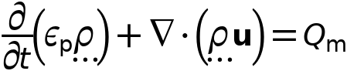

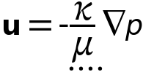

##### Fluid Properties

Settings

| **Description** | **Value** | **Unit** |
| --- | --- | --- |
| Fluid type | Gas/Liquid |  |
| Density | User defined |  |
| Density | rho_f | kg/m³ |
| Dynamic viscosity | User defined |  |
| Dynamic viscosity | eta_f | Pa·s |

##### Variables

| **Name** | **Expression** | **Unit** | **Description** | **Selection** | **Details** |
| --- | --- | --- | --- | --- | --- |
| dl.porous.fluid.rho | dl.porous.fluid.rhomat | kg/m³ | Density | Domain 1 |  |
| dl.porous.fluid.rhomat | material.rho | kg/m³ | Density | Domain 1 | Meta |
| dl.porous.fluid.mu | material.mu | Pa·s | Dynamic viscosity | Domain 1 | Meta |
| dl.porous.fluid.chif | material.chif | 1/Pa | Compressibility of fluid | Domain 1 | Meta |
| dl.porous.fluid.prho | dl.porous1.fluid1.minput_pressure | Pa | Pressure for the evaluation of density | Domain 1 |  |
| dl.porous.fluid.Trho | dl.porous1.fluid1.minput_temperature | K | Temperature for density evaluation | Domain 1 |  |

#### Porous Matrix 1



Porous Matrix 1

Selection

|  |  |
| --- | --- |
| Geometric entity level | Domain |
| Selection | Geometry geom1: Dimension 2: All domains |

Equations

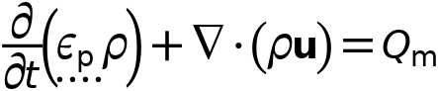



##### Matrix Properties

Settings

| **Description** | **Value** | **Unit** |
| --- | --- | --- |
| Porosity | User defined |  |
| Porosity | phi | 1 |
| Permeability model | Permeability |  |
| Permeability | User defined |  |
| Permeability | K | m² |

##### Variables

| **Name** | **Expression** | **Unit** | **Description** | **Selection** | **Details** |
| --- | --- | --- | --- | --- | --- |
| dl.porous.pm.epsilon | phi | 1 | Porosity | Domain 1 | + operation |
| dl.porous.pm.kappaXX | K | m² | Permeability, XX-component | Domain 1 |  |
| dl.porous.pm.kappaYX | 0 | m² | Permeability, YX-component | Domain 1 |  |
| dl.porous.pm.kappaZX | 0 | m² | Permeability, ZX-component | Domain 1 |  |
| dl.porous.pm.kappaXY | 0 | m² | Permeability, XY-component | Domain 1 |  |
| dl.porous.pm.kappaYY | K | m² | Permeability, YY-component | Domain 1 |  |
| dl.porous.pm.kappaZY | 0 | m² | Permeability, ZY-component | Domain 1 |  |
| dl.porous.pm.kappaXZ | 0 | m² | Permeability, XZ-component | Domain 1 |  |
| dl.porous.pm.kappaYZ | 0 | m² | Permeability, YZ-component | Domain 1 |  |
| dl.porous.pm.kappaZZ | K | m² | Permeability, ZZ-component | Domain 1 |  |
| dl.porous.pm.alpha | 1[1/m] | 1/m | Constitutive relation constant | Domain 1 |  |
| dl.porous.pm.l | 0.5 | 1 | Constitutive relation constant | Domain 1 |  |
| dl.porous.pm.n | 2 | 1 | Constitutive relation constant | Domain 1 |  |
| dl.porous.pm.m | 0.5 | 1 | Constitutive relation constant | Domain 1 |  |
| dl.porous.pm.theta_r | 0 | 1 | Residual liquid volume fraction | Domain 1 |  |

* + 1. No Flow 1

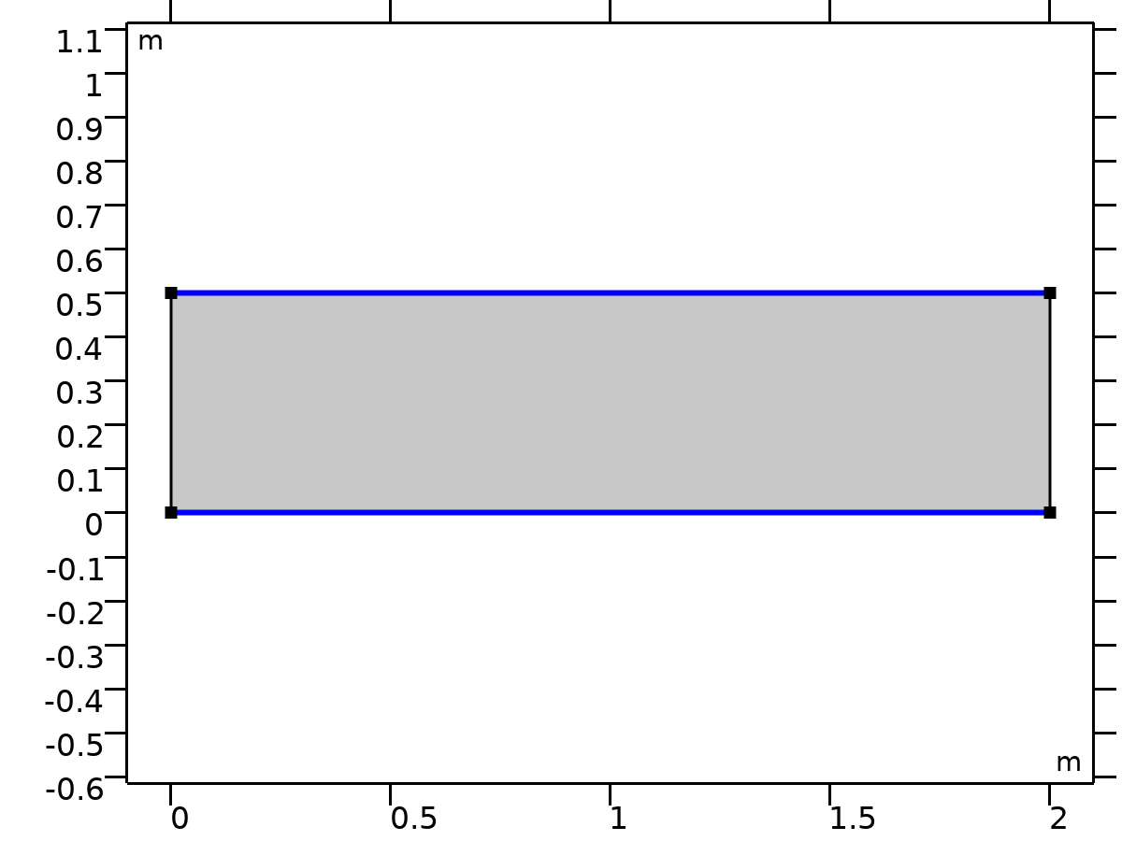

No Flow 1

Selection

|  |  |
| --- | --- |
| Geometric entity level | Boundary |
| Selection | Geometry geom1: Dimension 1: All boundaries |

Equations



* + 1. Initial Values 1



Initial Values 1

Selection

|  |  |
| --- | --- |
| Geometric entity level | Domain |
| Selection | Geometry geom1: Dimension 2: All domains |

#### Initial Values

Settings

| **Description** | **Value** | **Unit** |
| --- | --- | --- |
|  | Pressure |  |
| Pressure | 1000 | Pa |
| Pressure | 1000 | Pa |

* + 1. Pressure 1

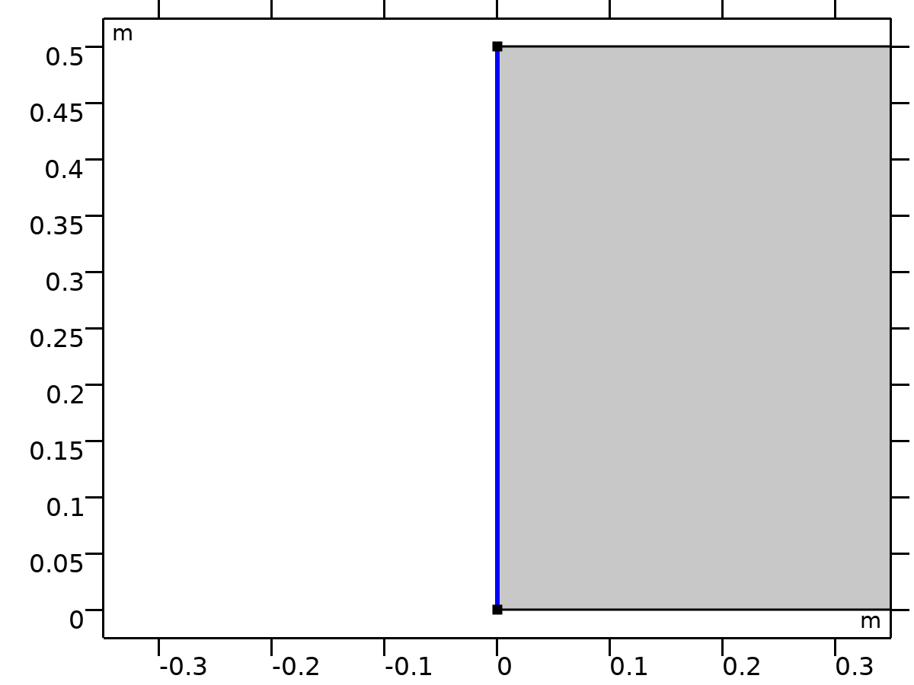

Pressure 1

Selection

|  |  |
| --- | --- |
| Geometric entity level | Boundary |
| Selection | Geometry geom1: Dimension 1: Boundary 1 |

Equations



#### Pressure

Settings

| **Description** | **Value** | **Unit** |
| --- | --- | --- |
| Pressure | 1000 | Pa |

#### Variables

| **Name** | **Expression** | **Unit** | **Description** | **Selection** | **Details** |
| --- | --- | --- | --- | --- | --- |
| dl.p0 | 1000 | Pa | Pressure | Boundary 1 |  |
| dl.pr1.varInt | dl.d | m | Intermediate variable | Boundary 1 | Meta |
| dl.pr1.Mflow | dl.pr1.intExtBnd(dl.bndflux*dl.pr1.varInt) | kg/s | Mass flow | Global |  |
| dl.pr1.Mflow_u | dl.pr1.intIntBnd(dl.bndflux_u*dl.pr1.varInt) | kg/s | Mass flow, upside | Global |  |
| dl.pr1.Mflow_d | dl.pr1.intIntBnd(dl.bndflux_d*dl.pr1.varInt) | kg/s | Mass flow, downside | Global |  |

#### Constraints

| **Constraint** | **Constraint force** | **Shape function** | **Selection** | **Details** |
| --- | --- | --- | --- | --- |
| p-dl.p0 | test(p-dl.p0) | Lagrange (Quadratic) | Boundary 1 | Elemental |

* + 1. Pressure 2

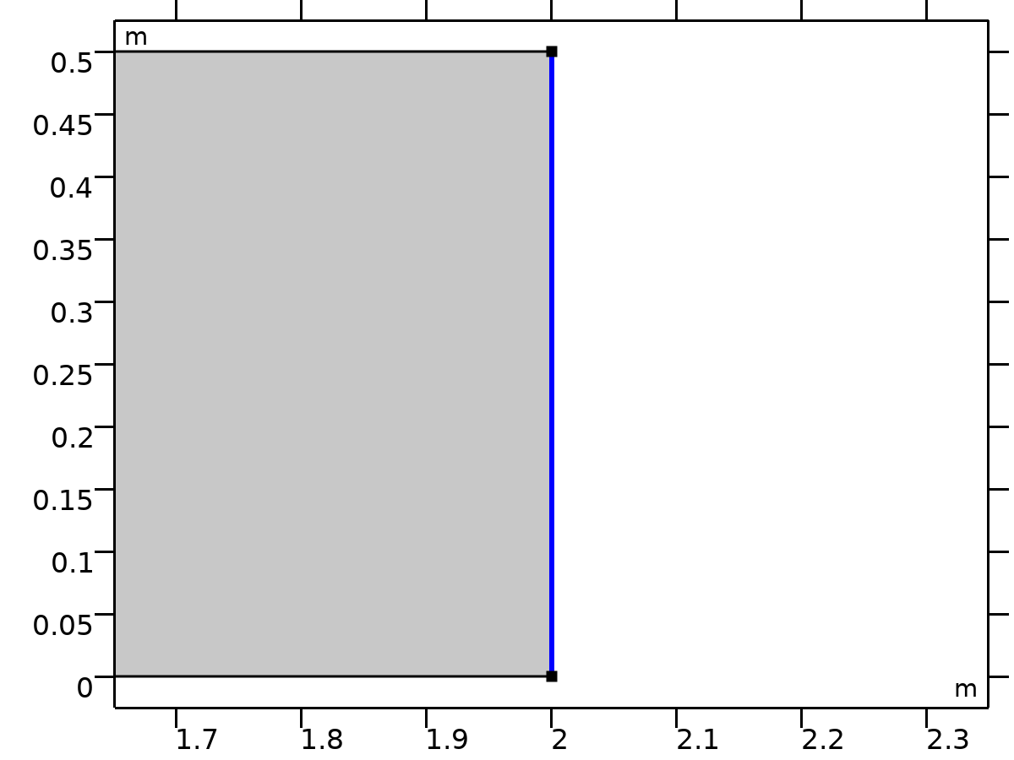

Pressure 2

Selection

|  |  |
| --- | --- |
| Geometric entity level | Boundary |
| Selection | Geometry geom1: Dimension 1: Boundary 4 |

Equations



#### Pressure

Settings

| **Description** | **Value** | **Unit** |
| --- | --- | --- |
| Pressure | 0 | Pa |

#### Variables

| **Name** | **Expression** | **Unit** | **Description** | **Selection** | **Details** |
| --- | --- | --- | --- | --- | --- |
| dl.p0 | 0 | Pa | Pressure | Boundary 4 |  |
| dl.pr2.varInt | dl.d | m | Intermediate variable | Boundary 4 | Meta |
| dl.pr2.Mflow | dl.pr2.intExtBnd(dl.bndflux*dl.pr2.varInt) | kg/s | Mass flow | Global |  |
| dl.pr2.Mflow_u | dl.pr2.intIntBnd(dl.bndflux_u*dl.pr2.varInt) | kg/s | Mass flow, upside | Global |  |
| dl.pr2.Mflow_d | dl.pr2.intIntBnd(dl.bndflux_d*dl.pr2.varInt) | kg/s | Mass flow, downside | Global |  |

#### Constraints

| **Constraint** | **Constraint force** | **Shape function** | **Selection** | **Details** |
| --- | --- | --- | --- | --- |
| p-dl.p0 | test(p-dl.p0) | Lagrange (Quadratic) | Boundary 4 | Elemental |

* 1. Electric Currents

Used products

|  |
| --- |
| COMSOL Multiphysics |



Electric Currents

Selection

|  |  |
| --- | --- |
| Geometric entity level | Domain |
| Selection | Geometry geom1: Dimension 2: All domains |

Equations



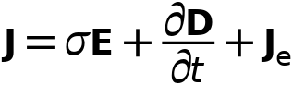



* + 1. Interface Settings

#### Discretization

Settings

| **Description** | **Value** |
| --- | --- |
| Electric potential | Quadratic |

Settings

| **Description** | **Value** |
| --- | --- |
| Equation form | Study controlled |

Settings

| **Description** | **Value** | **Unit** |
| --- | --- | --- |
| Out-of-plane thickness | 1 | m |

#### Manual Terminal Sweep Settings

Settings

| **Description** | **Value** | **Unit** |
| --- | --- | --- |
| Use manual terminal sweep | Off |  |
| Reference impedance | 50 | Ω |

* + 1. Variables

| **Name** | **Expression** | **Unit** | **Description** | **Selection** | **Details** |
| --- | --- | --- | --- | --- | --- |
| ec.d | 1 | m | Out-of-plane thickness | Domain 1 |  |
| ec.I_sXX | (spatial.invF11*(spatial.invF11*ec.I_sxx+spatial.invF21*ec.I_syx)+spatial.invF21*(spatial.invF11*ec.I_sxy+spatial.invF21*ec.I_syy))*spatial.detF | 1 | Spatial identity matrix, material frame, XX-component | Domain 1 |  |
| ec.I_sYX | (spatial.invF11*(spatial.invF12*ec.I_sxx+spatial.invF22*ec.I_syx)+spatial.invF21*(spatial.invF12*ec.I_sxy+spatial.invF22*ec.I_syy))*spatial.detF | 1 | Spatial identity matrix, material frame, YX-component | Domain 1 |  |
| ec.I_sZX | (spatial.invF11*ec.I_szx+spatial.invF21*ec.I_szy)*spatial.detF | 1 | Spatial identity matrix, material frame, ZX-component | Domain 1 |  |
| ec.I_sXY | (spatial.invF12*(spatial.invF11*ec.I_sxx+spatial.invF21*ec.I_syx)+spatial.invF22*(spatial.invF11*ec.I_sxy+spatial.invF21*ec.I_syy))*spatial.detF | 1 | Spatial identity matrix, material frame, XY-component | Domain 1 |  |
| ec.I_sYY | (spatial.invF12*(spatial.invF12*ec.I_sxx+spatial.invF22*ec.I_syx)+spatial.invF22*(spatial.invF12*ec.I_sxy+spatial.invF22*ec.I_syy))*spatial.detF | 1 | Spatial identity matrix, material frame, YY-component | Domain 1 |  |
| ec.I_sZY | (spatial.invF12*ec.I_szx+spatial.invF22*ec.I_szy)*spatial.detF | 1 | Spatial identity matrix, material frame, ZY-component | Domain 1 |  |
| ec.I_sXZ | (spatial.invF11*ec.I_sxz+spatial.invF21*ec.I_syz)*spatial.detF | 1 | Spatial identity matrix, material frame, XZ-component | Domain 1 |  |
| ec.I_sYZ | (spatial.invF12*ec.I_sxz+spatial.invF22*ec.I_syz)*spatial.detF | 1 | Spatial identity matrix, material frame, YZ-component | Domain 1 |  |
| ec.I_sZZ | ec.I_szz*spatial.detF | 1 | Spatial identity matrix, material frame, ZZ-component | Domain 1 |  |
| ec.I_sxx | 1 | 1 | Spatial identity matrix, xx-component | Domain 1 |  |
| ec.I_syx | 0 | 1 | Spatial identity matrix, yx-component | Domain 1 |  |
| ec.I_szx | 0 | 1 | Spatial identity matrix, zx-component | Domain 1 |  |
| ec.I_sxy | 0 | 1 | Spatial identity matrix, xy-component | Domain 1 |  |
| ec.I_syy | 1 | 1 | Spatial identity matrix, yy-component | Domain 1 |  |
| ec.I_szy | 0 | 1 | Spatial identity matrix, zy-component | Domain 1 |  |
| ec.I_sxz | 0 | 1 | Spatial identity matrix, xz-component | Domain 1 |  |
| ec.I_syz | 0 | 1 | Spatial identity matrix, yz-component | Domain 1 |  |
| ec.I_szz | 1 | 1 | Spatial identity matrix, zz-component | Domain 1 |  |
| ec.nx | dnx |  | Normal vector, x-component | Boundaries 1–4 |  |
| ec.ny | dny |  | Normal vector, y-component | Boundaries 1–4 |  |
| ec.nz | 0 |  | Normal vector, z-component | Boundaries 1–4 |  |
| ec.nmeshx | dnxmesh |  | Mesh normal vector, x-component | Boundaries 1–4 |  |
| ec.nmeshy | dnymesh |  | Mesh normal vector, y-component | Boundaries 1–4 |  |
| ec.nmeshz | 0 |  | Mesh normal vector, z-component | Boundaries 1–4 |  |
| ec.unmeshx | unxmesh |  | Mesh normal vector, upside, x-component | Boundaries 1–4 |  |
| ec.unmeshy | unymesh |  | Mesh normal vector, upside, y-component | Boundaries 1–4 |  |
| ec.unmeshz | 0 |  | Mesh normal vector, upside, z-component | Boundaries 1–4 |  |
| ec.dnmeshx | dnxmesh |  | Mesh normal vector, downside, x-component | Boundaries 1–4 |  |
| ec.dnmeshy | dnymesh |  | Mesh normal vector, downside, y-component | Boundaries 1–4 |  |
| ec.dnmeshz | 0 |  | Mesh normal vector, downside, z-component | Boundaries 1–4 |  |
| ec.unTx | ec.unTex | Pa | Maxwell upward surface stress tensor, x-component | Boundaries 1–4 |  |
| ec.unTy | ec.unTey | Pa | Maxwell upward surface stress tensor, y-component | Boundaries 1–4 |  |
| ec.unTz | ec.unTez | Pa | Maxwell upward surface stress tensor, z-component | Boundaries 1–4 |  |
| ec.dnTx | ec.dnTex | Pa | Maxwell downward surface stress tensor, x-component | Boundaries 1–4 |  |
| ec.dnTy | ec.dnTey | Pa | Maxwell downward surface stress tensor, y-component | Boundaries 1–4 |  |
| ec.dnTz | ec.dnTez | Pa | Maxwell downward surface stress tensor, z-component | Boundaries 1–4 |  |
| ec.unx | unx |  | Normal vector up direction, x-component | Boundaries 1–4 |  |
| ec.uny | uny |  | Normal vector up direction, y-component | Boundaries 1–4 |  |
| ec.unz | 0 |  | Normal vector up direction, z-component | Boundaries 1–4 |  |
| ec.dnx | dnx |  | Normal vector down direction, x-component | Boundaries 1–4 |  |
| ec.dny | dny |  | Normal vector down direction, y-component | Boundaries 1–4 |  |
| ec.dnz | 0 |  | Normal vector down direction, z-component | Boundaries 1–4 |  |
| ec.unTex | 0 | Pa | Maxwell upward electric surface stress tensor, x-component | Boundaries 1–4 |  |
| ec.unTey | 0 | Pa | Maxwell upward electric surface stress tensor, y-component | Boundaries 1–4 |  |
| ec.unTez | 0 | Pa | Maxwell upward electric surface stress tensor, z-component | Boundaries 1–4 |  |
| ec.dnTex | -0.5*ec.unx*(real(down(ec.Dx))*real(down(ec.Ex))+real(down(ec.Dy))*real(down(ec.Ey))+real(down(ec.Dz))*real(down(ec.Ez)))+real(down(ec.Dx))*(real(down(ec.Ex))*ec.unx+real(down(ec.Ey))*ec.uny+real(down(ec.Ez))*ec.unz) | Pa | Maxwell downward electric surface stress tensor, x-component | Boundaries 1–4 |  |
| ec.dnTey | -0.5*ec.uny*(real(down(ec.Dx))*real(down(ec.Ex))+real(down(ec.Dy))*real(down(ec.Ey))+real(down(ec.Dz))*real(down(ec.Ez)))+real(down(ec.Dy))*(real(down(ec.Ex))*ec.unx+real(down(ec.Ey))*ec.uny+real(down(ec.Ez))*ec.unz) | Pa | Maxwell downward electric surface stress tensor, y-component | Boundaries 1–4 |  |
| ec.dnTez | -0.5*ec.unz*(real(down(ec.Dx))*real(down(ec.Ex))+real(down(ec.Dy))*real(down(ec.Ey))+real(down(ec.Dz))*real(down(ec.Ez)))+real(down(ec.Dz))*(real(down(ec.Ex))*ec.unx+real(down(ec.Ey))*ec.uny+real(down(ec.Ez))*ec.unz) | Pa | Maxwell downward electric surface stress tensor, z-component | Boundaries 1–4 |  |
| ec.intWe | ec.int_We(ec.d*ec.dWe) | J | Total electric energy | Global | + operation |
| ec.Qh | 0 | W/m³ | Volumetric loss density, electromagnetic | Domain 1 |  |
| ec.Qsh | 0 | W/m² | Surface loss density, electromagnetic | Boundaries 1–4 |  |
| ec.Qlh | 0 | W/m | Line loss density, electromagnetic | Boundaries 1–4 |  |
| ec.zref | 50[ohm] | Ω | Reference impedance | Global |  |

* + 1. Current Conservation 1



Current Conservation 1

Selection

|  |  |
| --- | --- |
| Geometric entity level | Domain |
| Selection | Geometry geom1: Dimension 2: All domains |

Equations







#### Constitutive Relation Jc-E

Settings

| **Description** | **Value** | **Unit** |
| --- | --- | --- |
| Conduction model | Electrical conductivity |  |
| Electrical conductivity | User defined |  |
| Electrical conductivity | sigma_sat | S/m |

#### Constitutive Relation D-E

Settings

| **Description** | **Value** |
| --- | --- |
| Dielectric model | Relative permittivity |
| Relative permittivity | User defined |
| Relative permittivity | 1 |

#### Coordinate System Selection

Settings

| **Description** | **Value** |
| --- | --- |
| Coordinate system | Global coordinate system |

#### Variables

| **Name** | **Expression** | **Unit** | **Description** | **Selection** | **Details** |
| --- | --- | --- | --- | --- | --- |
| ec.Qh | ec.Qrh | W/m³ | Volumetric loss density, electromagnetic | Domain 1 |  |
| ec.Jex | 0 | A/m² | External current density, x-component | Domain 1 | + operation |
| ec.Jey | 0 | A/m² | External current density, y-component | Domain 1 | + operation |
| ec.Jez | 0 | A/m² | External current density, z-component | Domain 1 | + operation |
| ec.Jix | ec.sigmaxx*ec.Ex+ec.sigmaxy*ec.Ey+ec.sigmaxz*ec.Ez | A/m² | Conduction current density, x-component | Domain 1 |  |
| ec.Jiy | ec.sigmayx*ec.Ex+ec.sigmayy*ec.Ey+ec.sigmayz*ec.Ez | A/m² | Conduction current density, y-component | Domain 1 |  |
| ec.Jiz | ec.sigmazx*ec.Ex+ec.sigmazy*ec.Ey+ec.sigmazz*ec.Ez | A/m² | Conduction current density, z-component | Domain 1 |  |
| ec.Jdx | d(ec.Dx,t) | A/m² | Displacement current density, x-component | Domain 1 |  |
| ec.Jdy | d(ec.Dy,t) | A/m² | Displacement current density, y-component | Domain 1 |  |
| ec.Jdz | d(ec.Dz,t) | A/m² | Displacement current density, z-component | Domain 1 |  |
| ec.Jx | ec.Jix+ec.Jdx+ec.Jex | A/m² | Current density, x-component | Domain 1 |  |
| ec.Jy | ec.Jiy+ec.Jdy+ec.Jey | A/m² | Current density, y-component | Domain 1 |  |
| ec.Jz | ec.Jiz+ec.Jdz+ec.Jez | A/m² | Current density, z-component | Domain 1 |  |
| ec.normJ | sqrt(realdot(ec.Jx,ec.Jx)+realdot(ec.Jy,ec.Jy)+realdot(ec.Jz,ec.Jz)) | A/m² | Current density norm | Domain 1 |  |
| ec.rhoq | ppr(d(ec.Dx,x)+d(ec.Dy,y)) | C/m³ | Space charge density | Domain 1 |  |
| ec.sigmaxx | material.sigma11 | S/m | Electrical conductivity, xx-component | Domain 1 | Meta |
| ec.sigmayx | material.sigma21 | S/m | Electrical conductivity, yx-component | Domain 1 | Meta |
| ec.sigmazx | material.sigma31 | S/m | Electrical conductivity, zx-component | Domain 1 | Meta |
| ec.sigmaxy | material.sigma12 | S/m | Electrical conductivity, xy-component | Domain 1 | Meta |
| ec.sigmayy | material.sigma22 | S/m | Electrical conductivity, yy-component | Domain 1 | Meta |
| ec.sigmazy | material.sigma32 | S/m | Electrical conductivity, zy-component | Domain 1 | Meta |
| ec.sigmaxz | material.sigma13 | S/m | Electrical conductivity, xz-component | Domain 1 | Meta |
| ec.sigmayz | material.sigma23 | S/m | Electrical conductivity, yz-component | Domain 1 | Meta |
| ec.sigmazz | material.sigma33 | S/m | Electrical conductivity, zz-component | Domain 1 | Meta |
| ec.sigma_iso | material.sigma_iso | S/m | Electrical conductivity, isotropic value | Domain 1 | Meta |
| ec.epsilonrxx | 1 | 1 | Relative permittivity, xx-component | Domain 1 |  |
| ec.epsilonryx | 0 | 1 | Relative permittivity, yx-component | Domain 1 |  |
| ec.epsilonrzx | 0 | 1 | Relative permittivity, zx-component | Domain 1 |  |
| ec.epsilonrxy | 0 | 1 | Relative permittivity, xy-component | Domain 1 |  |
| ec.epsilonryy | 1 | 1 | Relative permittivity, yy-component | Domain 1 |  |
| ec.epsilonrzy | 0 | 1 | Relative permittivity, zy-component | Domain 1 |  |
| ec.epsilonrxz | 0 | 1 | Relative permittivity, xz-component | Domain 1 |  |
| ec.epsilonryz | 0 | 1 | Relative permittivity, yz-component | Domain 1 |  |
| ec.epsilonrzz | 1 | 1 | Relative permittivity, zz-component | Domain 1 |  |
| ec.epsilonr_iso | 1 | 1 | Relative permittivity, isotropic value | Domain 1 |  |
| ec.Dx | epsilon0_const*ec.I_sxx*ec.Ex+epsilon0_const*ec.I_sxy*ec.Ey+epsilon0_const*ec.I_sxz*ec.Ez+ec.Px+ec.Pex+ec.Phx | C/m² | Electric displacement field, x-component | Domain 1 |  |
| ec.Dy | epsilon0_const*ec.I_syx*ec.Ex+epsilon0_const*ec.I_syy*ec.Ey+epsilon0_const*ec.I_syz*ec.Ez+ec.Py+ec.Pey+ec.Phy | C/m² | Electric displacement field, y-component | Domain 1 |  |
| ec.Dz | epsilon0_const*ec.I_szx*ec.Ex+epsilon0_const*ec.I_szy*ec.Ey+epsilon0_const*ec.I_szz*ec.Ez+ec.Pz+ec.Pez+ec.Phz | C/m² | Electric displacement field, z-component | Domain 1 |  |
| ec.Px | epsilon0_const*(ec.chixx*ec.Ex+ec.chixy*ec.Ey+ec.chixz*ec.Ez) | C/m² | Polarization, x-component | Domain 1 |  |
| ec.Py | epsilon0_const*(ec.chiyx*ec.Ex+ec.chiyy*ec.Ey+ec.chiyz*ec.Ez) | C/m² | Polarization, y-component | Domain 1 |  |
| ec.Pz | epsilon0_const*(ec.chizx*ec.Ex+ec.chizy*ec.Ey+ec.chizz*ec.Ez) | C/m² | Polarization, z-component | Domain 1 |  |
| ec.normD | sqrt(realdot(ec.Dx,ec.Dx)+realdot(ec.Dy,ec.Dy)+realdot(ec.Dz,ec.Dz)) | C/m² | Electric displacement field norm | Domain 1 |  |
| ec.normP | sqrt(realdot(ec.Px,ec.Px)+realdot(ec.Py,ec.Py)+realdot(ec.Pz,ec.Pz)) | C/m² | Polarization norm | Domain 1 |  |
| ec.Pex | 0 | C/m² | Polarization contribution, x-component | Domain 1 | + operation |
| ec.Pey | 0 | C/m² | Polarization contribution, y-component | Domain 1 | + operation |
| ec.Pez | 0 | C/m² | Polarization contribution, z-component | Domain 1 | + operation |
| ec.Phx | 0 | C/m² | Polarization contribution, x-component | Domain 1 | + operation |
| ec.Phy | 0 | C/m² | Polarization contribution, y-component | Domain 1 | + operation |
| ec.Phz | 0 | C/m² | Polarization contribution, z-component | Domain 1 | + operation |
| ec.chixx | -1+ec.epsilonrxx | 1 | Electric susceptibility, xx-component | Domain 1 |  |
| ec.chiyx | ec.epsilonryx | 1 | Electric susceptibility, yx-component | Domain 1 |  |
| ec.chizx | ec.epsilonrzx | 1 | Electric susceptibility, zx-component | Domain 1 |  |
| ec.chixy | ec.epsilonrxy | 1 | Electric susceptibility, xy-component | Domain 1 |  |
| ec.chiyy | -1+ec.epsilonryy | 1 | Electric susceptibility, yy-component | Domain 1 |  |
| ec.chizy | ec.epsilonrzy | 1 | Electric susceptibility, zy-component | Domain 1 |  |
| ec.chixz | ec.epsilonrxz | 1 | Electric susceptibility, xz-component | Domain 1 |  |
| ec.chiyz | ec.epsilonryz | 1 | Electric susceptibility, yz-component | Domain 1 |  |
| ec.chizz | -1+ec.epsilonrzz | 1 | Electric susceptibility, zz-component | Domain 1 |  |
| ec.Ex | -Vx | V/m | Electric field, x-component | Domain 1 |  |
| ec.Ey | -Vy | V/m | Electric field, y-component | Domain 1 |  |
| ec.Ez | 0 | V/m | Electric field, z-component | Domain 1 |  |
| ec.tEx | -VTx | V/m | Tangential electric field, x-component | Boundaries 1–4 |  |
| ec.tEy | -VTy | V/m | Tangential electric field, y-component | Boundaries 1–4 |  |
| ec.tEz | 0 | V/m | Tangential electric field, z-component | Boundaries 1–4 |  |
| ec.normE | sqrt(realdot(ec.Ex,ec.Ex)+realdot(ec.Ey,ec.Ey)+realdot(ec.Ez,ec.Ez)) | V/m | Electric field norm | Domain 1 |  |
| ec.Qrh | (ec.Jix+ec.Jex)*ec.Ex+(ec.Jiy+ec.Jey)*ec.Ey+(ec.Jiz+ec.Jez)*ec.Ez | W/m³ | Volumetric loss density, electric | Domain 1 | + operation |
| ec.W | ec.We | J/m³ | Energy density | Domain 1 | + operation |
| ec.dWe | ec.We | J/m³ | Integrand for total electric energy | Domain 1 | Meta |
| ec.We | 0.5*epsilon0_const*(((ec.I_sxx+ec.chixx)*ec.Ex+(ec.I_sxy+ec.chixy)*ec.Ey+(ec.I_sxz+ec.chixz)*ec.Ez)*ec.Ex+((ec.I_syx+ec.chiyx)*ec.Ex+(ec.I_syy+ec.chiyy)*ec.Ey+(ec.I_syz+ec.chiyz)*ec.Ez)*ec.Ey+((ec.I_szx+ec.chizx)*ec.Ex+(ec.I_szy+ec.chizy)*ec.Ey+(ec.I_szz+ec.chizz)*ec.Ez)*ec.Ez) | J/m³ | Electric energy density | Domain 1 |  |
| ec.rhoqs | -ec.dnx*down(ec.Dx)-ec.dny*down(ec.Dy)-ec.dnz*down(ec.Dz) | C/m² | Surface charge density | Boundaries 1–4 |  |

#### Shape functions

| **Name** | **Shape function** | **Unit** | **Description** | **Shape frame** | **Selection** |
| --- | --- | --- | --- | --- | --- |
| V | Lagrange (Quadratic) | V | Electric potential | Spatial | Domain 1 |
| V | Lagrange (Quadratic) | V | Electric potential | Material | Domain 1 |
| V | Lagrange (Quadratic) | V | Electric potential | Geometry | Domain 1 |
| V | Lagrange (Quadratic) | V | Electric potential | Mesh | Domain 1 |

#### Weak Expressions

| **Weak expression** | **Integration order** | **Integration frame** | **Selection** |
| --- | --- | --- | --- |
| (ec.Jx*test(Vx)+ec.Jy*test(Vy))*ec.d | 4 | Spatial | Domain 1 |

* + 1. Electric Insulation 1

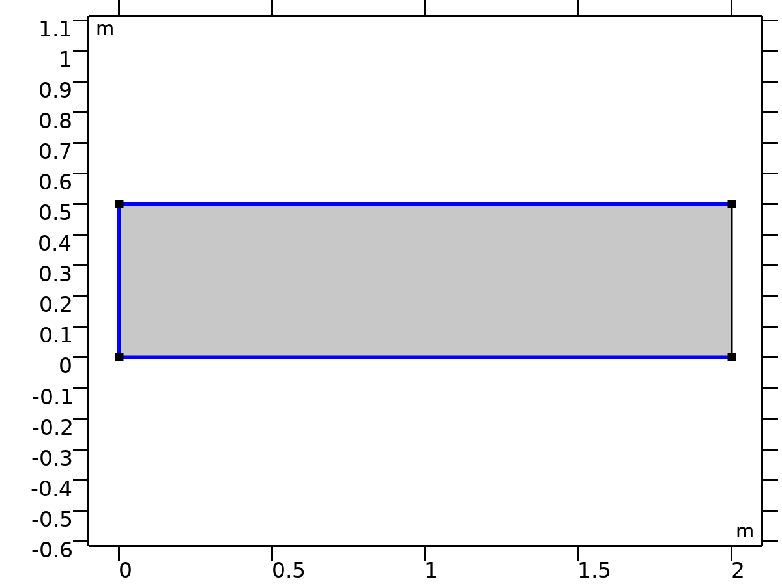

Electric Insulation 1

Selection

|  |  |
| --- | --- |
| Geometric entity level | Boundary |
| Selection | Geometry geom1: Dimension 1: All boundaries |

Equations



#### Variables

| **Name** | **Expression** | **Unit** | **Description** | **Selection** | **Details** |
| --- | --- | --- | --- | --- | --- |
| ec.nJ | 0 | A/m² | Normal current density | Boundaries 1–3 | + operation |

#### Shape functions

| **Name** | **Shape function** | **Unit** | **Description** | **Shape frame** | **Selection** | **Details** |
| --- | --- | --- | --- | --- | --- | --- |
| V | Lagrange (Quadratic) | V | Electric potential | Spatial | No boundaries | Slit |
| V | Lagrange (Quadratic) | V | Electric potential | Material | No boundaries | Slit |
| V | Lagrange (Quadratic) | V | Electric potential | Geometry | No boundaries | Slit |
| V | Lagrange (Quadratic) | V | Electric potential | Mesh | No boundaries | Slit |

* + 1. Initial Values 1



Initial Values 1

Selection

|  |  |
| --- | --- |
| Geometric entity level | Domain |
| Selection | Geometry geom1: Dimension 2: All domains |

Settings

| **Description** | **Value** | **Unit** |
| --- | --- | --- |
| Electric potential | 0 | V |

* + 1. External Current Density 1



External Current Density 1

Selection

|  |  |
| --- | --- |
| Geometric entity level | Domain |
| Selection | Geometry geom1: Dimension 2: Domain 1 |

Equations



#### External Current Density

Settings

| **Description** | **Value** | **Unit** |
| --- | --- | --- |
| External current density, x-component | js_x | A/m² |
| External current density, y-component | js_y | A/m² |
| External current density, z-component | 0 | A/m² |
| Add contribution of the external current density to the losses | Off |  |

#### Coordinate System Selection

Settings

| **Description** | **Value** |
| --- | --- |
| Coordinate system | Global coordinate system |

#### Variables

| **Name** | **Expression** | **Unit** | **Description** | **Selection** | **Details** |
| --- | --- | --- | --- | --- | --- |
| ec.Jex | ec.ecd1.Jex | A/m² | External current density, x-component | Domain 1 | + operation |
| ec.Jey | ec.ecd1.Jey | A/m² | External current density, y-component | Domain 1 | + operation |
| ec.Jez | ec.ecd1.Jez | A/m² | External current density, z-component | Domain 1 | + operation |
| ec.ecd1.Jex | js_x | A/m² | External current density, x-component | Domain 1 |  |
| ec.ecd1.Jey | js_y | A/m² | External current density, y-component | Domain 1 |  |
| ec.ecd1.Jez | 0 | A/m² | External current density, z-component | Domain 1 |  |

* + 1. Ground 1



Ground 1

Selection

|  |  |
| --- | --- |
| Geometric entity level | Boundary |
| Selection | Geometry geom1: Dimension 1: Boundary 4 |

Equations



#### Variables

| **Name** | **Expression** | **Unit** | **Description** | **Selection** | **Details** |
| --- | --- | --- | --- | --- | --- |
| ec.nJ | ec.unx*down(ec.Jx)+ec.uny*down(ec.Jy)+ec.unz*down(ec.Jz) | A/m² | Normal current density | Boundary 4 | + operation |
| ec.V0 | 0 | V | Electric potential | Boundary 4 |  |

#### Constraints

| **Constraint** | **Constraint force** | **Shape function** | **Selection** | **Details** |
| --- | --- | --- | --- | --- |
| ec.V0-V | test(ec.V0-V) | Lagrange (Quadratic) | Boundary 4 | Elemental |

* 1. Mesh 1

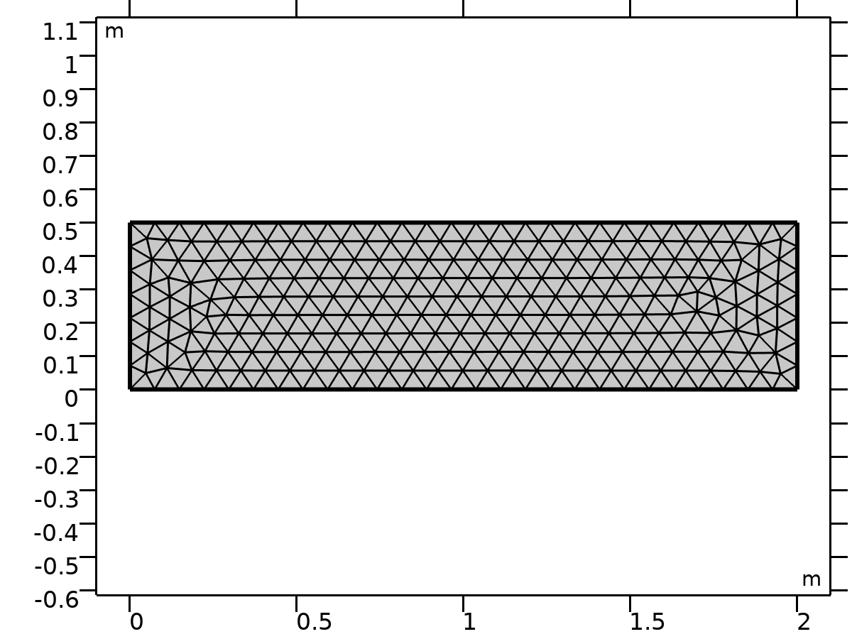

Mesh 1

Mesh statistics

| **Description** | **Value** |
| --- | --- |
| Status | Complete mesh |
| Mesh vertices | 280 |
| Triangles | 490 |
| Edge elements | 68 |
| Vertex elements | 4 |
| Number of elements | 490 |
| Minimum element quality | 0.7136 |
| Average element quality | 0.8905 |
| Element area ratio | 0.51159 |
| Mesh area | 1 m² |

* + 1. Size (size)

Settings

| **Description** | **Value** |
| --- | --- |
| Maximum element size | 0.074 |
| Minimum element size | 2.5E-4 |
| Curvature factor | 0.25 |
| Maximum element growth rate | 1.25 |
| Predefined size | Finer |

* + 1. Free Triangular 1 (ftri1)

Selection

|  |  |
| --- | --- |
| Geometric entity level | Domain |
| Selection | Remaining |

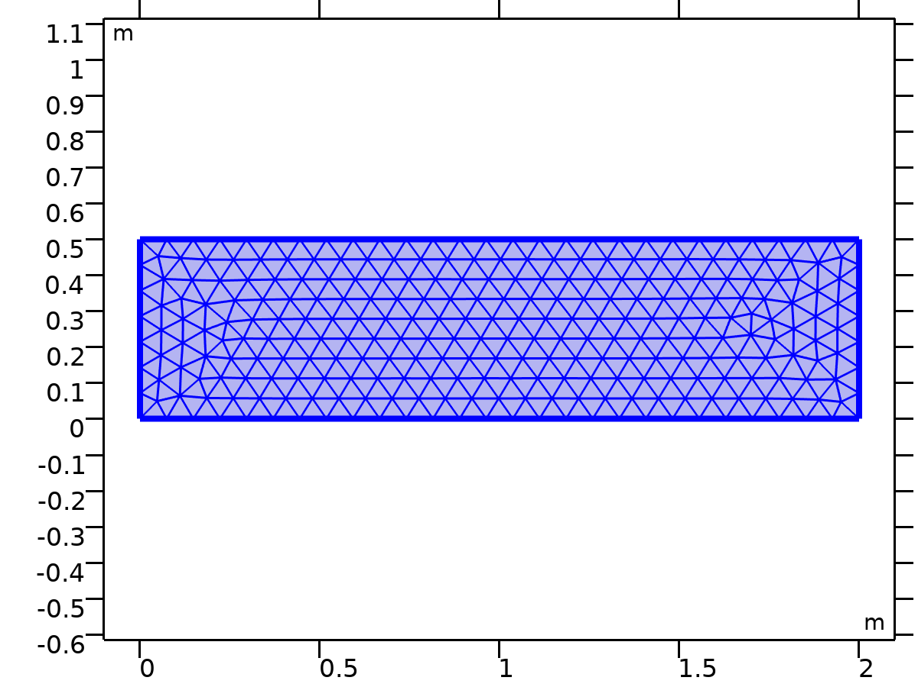

Free Triangular 1

Settings

| **Description** | **Value** |
| --- | --- |
| Number of iterations | 4 |
| Maximum element depth to process | 4 |
| Last build time | 0 |
| Built with | COMSOL 6.1.0.252 (win64)|2025 - 05 - 13T17:43:09.749886400 |

1. Study 1

Computation information

|  |  |
| --- | --- |
| Computation time | 2 s |

* 1. Time Dependent

| **Times** | **Unit** |
| --- | --- |
| range(0, 10, 300) | s |

Study settings

| **Description** | **Value** |
| --- | --- |
| Include geometric nonlinearity | Off |

Study settings

| **Description** | **Value** |
| --- | --- |
| Output times | {0, 10, 20, 30, 40, 50, 60, 70, 80, 90, 100, 110, 120, 130, 140, 150, 160, 170, 180, 190, 200, 210, 220, 230, 240, 250, 260, 270, 280, 290, 300} |

Physics and variables selection

| **Physics interface** | **Discretization** |
| --- | --- |
| Darcy's Law (dl) | physics |
| Electric Currents (ec) | physics |

Mesh selection

| **Geometry** | **Mesh** |
| --- | --- |
| Geometry 1 (geom1) | mesh1 |

* 1. Solver Configurations
     1. Solution 1

#### Compile Equations: Time Dependent (st1)

Study and step

| **Description** | **Value** |
| --- | --- |
| Use study | Study 1 |
| Use study step | Time Dependent |

Log

<---- Compile Equations: Time Dependent in Study 1/Solution 1 (sol1) -----------

Started at May 13, 2025, 5:44:08 PM.

Geometry shape function: Quadratic Lagrange

Running on Intel64 Family 6 Model 154 Stepping 4, GenuineIntel.

Using 1 socket with 12 cores in total on DELL_12.

Available memory: 7.88 GB.

Time: 1 s.

Physical memory: 1.17 GB

Virtual memory: 1.33 GB

Ended at May 13, 2025, 5:44:09 PM.

----- Compile Equations: Time Dependent in Study 1/Solution 1 (sol1) ---------->

#### Dependent Variables 1 (v1)

General

| **Description** | **Value** |
| --- | --- |
| Defined by study step | Time Dependent |

Residual scaling

| **Description** | **Value** |
| --- | --- |
| Method | Manual |

Initial value calculation constants

| **Constant name** | **Initial value source** |
| --- | --- |
| t | range(0, 10, 300) |
| timestep | 0.3[s] |

Log

<---- Dependent Variables 1 in Study 1/Solution 1 (sol1) -----------------------

Started at May 13, 2025, 5:44:09 PM.

Solution time: 0 s.

Physical memory: 1.18 GB

Virtual memory: 1.33 GB

Ended at May 13, 2025, 5:44:09 PM.

----- Dependent Variables 1 in Study 1/Solution 1 (sol1) ---------------------->

##### Pressure (comp1.p) (comp1_p)

General

| **Description** | **Value** |
| --- | --- |
| Field components | comp1.p |

##### Electric potential (comp1.V) (comp1_V)

General

| **Description** | **Value** |
| --- | --- |
| Field components | comp1.V |

#### Time-Dependent Solver 1 (t1)

General

| **Description** | **Value** |
| --- | --- |
| Defined by study step | Time Dependent |
| Output times | {0, 10, 20, 30, 40, 50, 60, 70, 80, 90, 100, 110, 120, 130, 140, 150, 160, 170, 180, 190, 200, 210, 220, 230, 240, 250, 260, 270, 280, 290, 300} |
| Relative tolerance | 0.005 |

Time stepping

| **Description** | **Value** |
| --- | --- |
| Maximum BDF order | 2 |
| Nonlinear controller | On |

Log

<---- Time-Dependent Solver 1 in Study 1/Solution 1 (sol1) ---------------------

Started at May 13, 2025, 5:44:09 PM.

Time-dependent solver (BDF)

Number of degrees of freedom solved for: 2098.

Nonsymmetric matrix found.

Scales for dependent variables:

Pressure (comp1.p): 1e+03

Electric potential (comp1.V): 7.6e+04

Step        Time    Stepsize      Res  Jac  Sol Order Tfail NLfail   LinErr   LinRes

   0           0           - out    4    3    4                  0  4.4e-14  3.5e-14

   1         0.3         0.3        6    4    6     1     0      0  3.3e-14  7.5e-15

   2         0.6         0.3        7    5    7     1     0      0  3.4e-14  6.1e-14

   3         1.2         0.6        8    6    8     2     0      0  3.3e-14    6e-14

   4         2.4         1.2        9    7    9     1     0      0  2.6e-14  3.5e-15

   5         4.8         2.4       10    8   10     1     0      0  3.7e-14  5.3e-15

   6         9.6         4.8       11    9   11     1     0      0  4.5e-14    1e-14

   -          10           - out

   7        19.2         9.6       12   10   12     1     0      0  4.4e-14  8.8e-15

   -          20           - out

   -          30           - out

   8        38.4        19.2       13   11   13     1     0      0  2.5e-14  1.6e-15

   -          40           - out

   -          50           - out

   -          60           - out

   9        68.4          30       14   12   14     1     0      0  3.3e-14  3.5e-15

   -          70           - out

   -          80           - out

   -          90           - out

  10        98.4          30       15   13   15     1     0      0  4.2e-14  2.8e-15

   -         100           - out

   -         110           - out

   -         120           - out

  11       128.4          30       16   14   16     1     0      0  4.7e-14  3.6e-15

   -         130           - out

   -         140           - out

   -         150           - out

  12       158.4          30       17   15   17     1     0      0  4.8e-14  8.1e-15

   -         160           - out

   -         170           - out

   -         180           - out

  13       188.4          30       18   16   18     1     0      0  4.8e-14  9.1e-15

   -         190           - out

   -         200           - out

   -         210           - out

  14       218.4          30       19   17   19     1     0      0  4.7e-14    1e-14

   -         220           - out

   -         230           - out

   -         240           - out

  15       248.4          30       20   18   20     1     0      0    3e-14  1.5e-14

   -         250           - out

   -         260           - out

   -         270           - out

  16       278.4          30       21   19   21     1     0      0    4e-14  1.1e-14

   -         280           - out

   -         290           - out

   -         300           - out

  17       308.4          30       22   20   22     1     0      0  3.7e-14  5.1e-15

Time-stepping completed.

Solution time: 1 s.

Physical memory: 1.2 GB

Virtual memory: 1.35 GB

Ended at May 13, 2025, 5:44:10 PM.

----- Time-Dependent Solver 1 in Study 1/Solution 1 (sol1) -------------------->

##### Advanced (aDef)

Assembly settings

| **Description** | **Value** |
| --- | --- |
| Reuse sparsity pattern | On |

##### Fully Coupled 1 (fc1)

General

| **Description** | **Value** |
| --- | --- |
| Linear solver | Direct, pressure (dl) (merged) |

Method and termination

| **Description** | **Value** |
| --- | --- |
| Jacobian update | Once per time step |
| Maximum number of iterations | 8 |
| Stabilization and acceleration | Anderson acceleration |
| Dimension of iteration space | 5 |
| Mixing parameter | 0.9 |

1. Results
   1. Datasets
      1. Study 1/Solution 1

Solution

| **Description** | **Value** |
| --- | --- |
| Solution | Solution 1 |
| Component | Component 1 (comp1) |

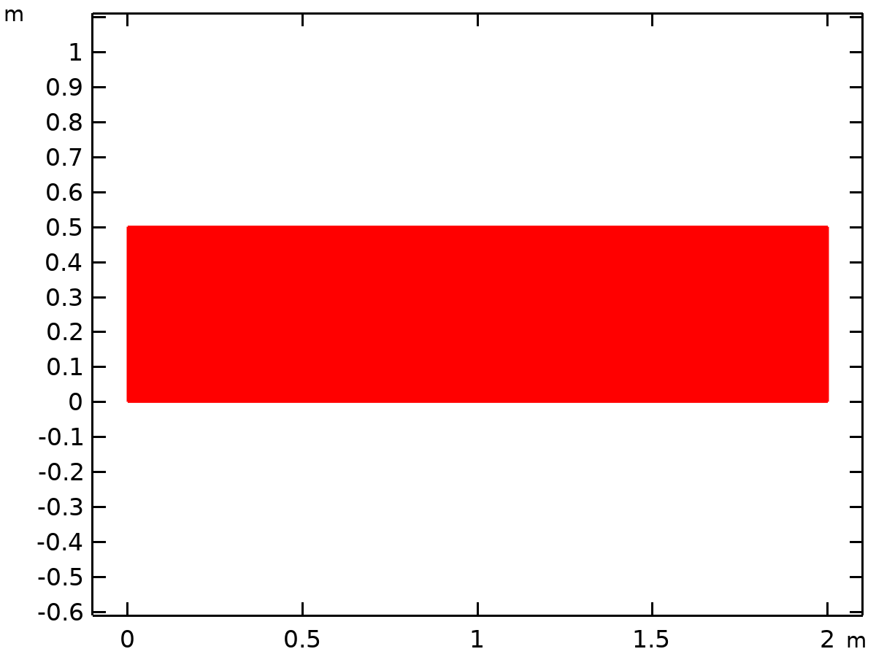

Dataset: Study 1/Solution 1

* 1. Plot Groups
     1. Pressure (dl)

[COMSOLlink[]]

Surface: Pressure (Pa) Streamline: Darcy's velocity field

* + 1. Electric Potential (ec)

[COMSOLlink[]]

Surface: Electric potential (V)

* + 1. Electric Field Norm (ec)

[COMSOLlink[]]

Surface: Electric field norm (V/m)